

FULLERTON HEALTHCARE AUSTRALIA

Functional Specification Documentation

Interface to SAP

Revision History

Ver. # | Date | Prepared By | Significant Changes | Reviewed By
1.0 | 18/6/2015 | Boorla Srinivas | Initial Document

Table of Content

INTERGRATION MECHANISM 3
OVERVIEW 3
DATA EXCHANGE FORMAT 3
FILE NAMING CONVENTION 3
FILE GENERATION SCHEDULE - DAILY 4
FILE DELIVERY 4
1. CSN (iCarus System) INTERFACE 4
2. FAH (front desk system)/MED (Best Practice) INTERFACE 4

INTERGRATION MECHANISM

OVERVIEW

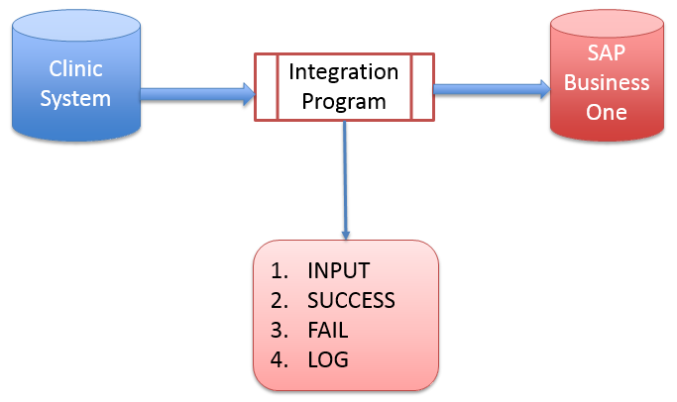

- Integration process is one way (Clinics to SAP B1)
- Integration program runs via batch automatically
- There are 4 folders need to be created on Virtual Machine server
- INPUT - This folder will keep the original file from Clinic and POS System (csv file) before imported to SAP Business One system. Mode of transfer form source (Info care ) folder to input (SAP) folder is via batch job execution.
- SUCCESS - This folder consists of all successful imported files.
- FAIL - This folder consists of all fail imported files.
- LOG – This folder consists of Debug & error log files.

DATA EXCHANGE FORMAT

Data Exchange Format | CSV (Text File)
Filed Separator | [ , ] (comma)
Field Delimiter | [ “ ] (double quote)

FILE NAMING CONVENTION

Fullerton Allied Health Pty Ltd (FAH)  Front Desk system  A/R Invoice File Naming | FAH_AR_yyyymmdd_hhnn.txt
Medicheck Australia Pty Ltd (MED)  Best Practice  A/R Invoice File Naming  Incoming Payment File Naming | MED_AR_yyyymmdd_hhnn.txt  MED_RC_yyyymmdd_hhnn.txt
Jobfit Health Group Pty Ltd (JHG)  Health monitoring system  A/R Invoice File Naming | JHG_AR_yyyymmdd_hhnn.txt
Corporate Services Network Pty Ltd (CSN)  iCarus  A/R Invoice File Naming | CSN_AR_yyyymmdd_hhnn.txt

FILE GENERATION SCHEDULE - DAILY

File generation schedule – Daily Interface | 9:00 PM every day

FILE DELIVERY

Options | FTP, Copy to folder

CSN (iCarus System) INTERFACE

This Interface will extract the data from CSN in .CSV file and Integrates with SAP Business one.
A/R Invoice document will be created in SAP B1. Below are the mapping details.

Column Name | SAP Filed Name | Type | Remarks
Invoice Number | U_AI_RefDocNum | NVARCHAR | iCarus Invoice Number
Item No | INV1.Itemcode/description | NVARCAHR | if services is with item code (if not applicable leave it blank)
GL Code | INV1.AcctCode | NVARCHAR | GL revenue code
Additional Information | INV1.Text |  | line memo or description of service invoice
Quantity | INV1.qty | INT | default to 1
GST Amount | INV1.taxamount | NUMERIC | GST amount of Invoice
Total | INV1.LineTotal | NUMERIC | invoice amount including GST
Sent On | OINV.DocDate | DATE | Date of Invoice sent to Customer
Document Type | U_AI_BenefitType | NVARCHAR | type of Invoice services
Insurer | U_AI_INSURER | NVARCHAR | Insurer name
Customer Code | OINV.CardCode | NVARCHAR | Customer Code
Direct Invoicing | OINV.CardName | NVARCHAR | Customer Name
Others | U_AI_NATURE | NVARCHAR
Branch Code | INV1.ocrcode2 (auto populate inv1.ocrcode5) | NVARCHAR

FAH (Front Desk System)/MED(Best Practice) INTERFACE

This Interface will extract the data from FAH (Front Desk System) in .CSV file and Integrates with SAP Business one.

Check invoice no. exist in the SAP system, if yes create credit memo based on A/R invoice and create a new invoice as per Revised Amount.
Below are the mapping details.

Column Name | SAP Filed Name | Type | Remarks
EntityCode |  | NVARCHAR | Entity code to identify the database.
InvoiceDate | OINV.DOCDATE | DATE
VisitDate | INV1.U_AI_VISITDATE | DATE
InvoiceNo | OINV.U_AI_RefDocNum | NVARCHAR
Customer Code | OINV.CARDCODE | NVARCHAR
Customer Name | OINV.CARDNAME | NVARCHAR
Item Code | INV1.ITEMCODE | NVARCHAR
Item Description | INV1.DESCRIPTION | NVARCHAR
GST | INV1.TAXAMOUNT
Total Amount | INV1.LINETOTAL | NUMERIC
Revised Amount | INV1.LINETOTAL | NUMERIC
Patient Name | OINV.U_AI_APPLICANT | NVARCHAR
Doctor Name | OINV. U_AI_EXAMINER | NVARCHAR
Provider Name | U_AI_CompanyName | NVARCHAR
Branch Code | INV1.OCRCODE2 | NVARCHAR

